**COVID-19 Detection from Chest X-ray and CT-Scans Using Deep Learning**

*A Project Based Learning Report Submitted in partial fulfilment of the requirements for the award of the degree*

*of*

**Bachelor of Technology in**

**Department of Electronics and Communication Engineering**

**22AIP3305A- DEEP LEARNING**

Submitted by

**2210040005: Sweety**

**2210040024: Sruthi**

**2210040037: Ram Charan**

**2210040067: Akshitha**

**2210040068: Manisha**

Under the guidance of

**Dr. Sumit Hazra**



Department of Electronics and Communication Engineering

Koneru Lakshmaiah Education Foundation, Aziz Nagar

Aziz Nagar – 500075

**COVID-19 Detection from Chest X-ray and CT-Scans Using Deep Learning**

**1. Project Overview:**

The COVID-19 pandemic has significantly impacted global healthcare systems, necessitating rapid and accurate diagnosis methods. This project focuses on detecting COVID-19 from **chest X-ray (CXR) and computed tomography (CT) scan images** using deep learning. Traditional diagnostic techniques such as RT-PCR tests are time-consuming, whereas AI-driven image analysis can provide faster and more reliable results. We employ **EfficientNet** and **DenseNet** deep learning models to classify medical images, aiming to assist radiologists in detecting COVID-19 cases efficiently.

**2. Key Concepts:**

1. **Medical Image Processing** – Utilizing image enhancement techniques for better feature extraction from X-ray and CT scans.
2. **Deep Learning Models** – Applying convolutional neural networks (CNNs), specifically **EfficientNet and DenseNet**, for COVID-19 detection.
3. **Transfer Learning** – Fine-tuning pre-trained models on COVID-19 datasets to improve classification accuracy.
4. **Binary and Multi-Class Classification** – Distinguishing between **COVID-19, Pneumonia, and Normal lung conditions**.
5. **Performance Metrics** – Evaluating models using **accuracy, precision, recall, confusion matrix, and AUC-ROC curves**.

**3. Steps in Building the Project:**

**3.1 Data Collection and Preprocessing**

* Datasets collected from open-source repositories like **COVIDx, RSNA Pneumonia Dataset, and Kaggle COVID-19 Radiography Database**.
* Images resized to **224x224 pixels** for compatibility with deep learning models.
* Normalization applied to standardize pixel values.
* Data augmentation techniques such as **rotation, flipping, and contrast enhancement** implemented to improve generalization.

**3.2 Model Selection and Training**

* Compared **EfficientNet-B3** and **DenseNet121** for COVID-19 detection.
* Used **binary cross-entropy** loss function for two-class classification (COVID vs. Non-COVID).
* Applied **Adam optimizer** with a learning rate of **1e-4** and implemented **early stopping** to prevent overfitting.
* Trained the models on **80% of the dataset** and validated them on **20%**.

**3.3 Model Evaluation**

* Performance assessed using **accuracy, F1-score, precision, recall, and confusion matrix**.
* **Grad-CAM visualization** used to highlight regions of interest in the lungs that influenced predictions.
* **ROC-AUC curves** analyzed for model robustness in classification.

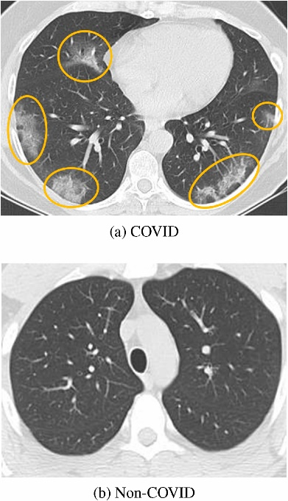

**3.4 Deployment**

* Converted the trained model into **TensorFlow Lite** for mobile compatibility.
* Developed a **Flask-based web application** to allow users to upload medical images and receive classification results in real-time.
* Integrated cloud storage to **store and analyze** patient images securely.

**4.Deep Learning Models Used**

**4.1. Efficient Net**

* A highly efficient CNN model designed using a compound scaling method.
* Provides better accuracy with fewer parameters compared to traditional CNNs.
* Used for its **high performance and lower computational cost**.

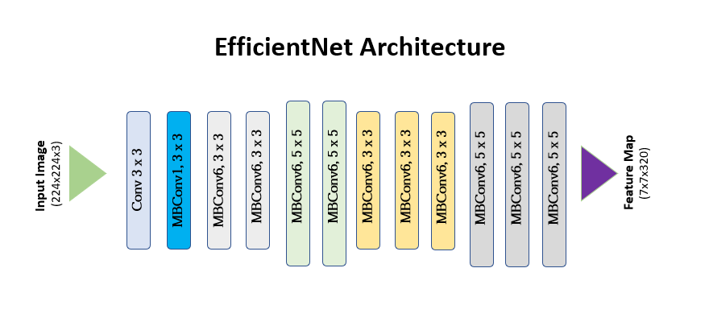

Fig.1.Efficient Architecture [1][2]

**4.2. DenseNet121**

* A deep convolutional network with densely connected layers.
* Reduces the vanishing gradient problem and enhances feature reuse.
* Applied for its **strong feature extraction capabilities** in medical imaging.

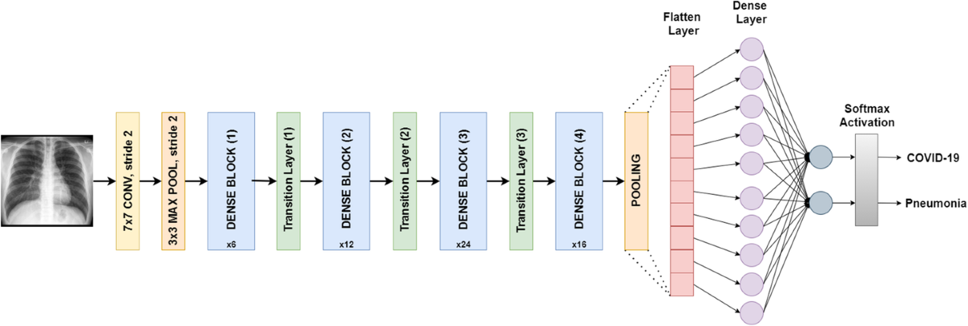

Fig.2.DenseNet121 Architecture [3]

**4.3. ResNet50 (Alternative Model)**

* A residual learning framework that helps train deeper networks.
* Used as a **baseline model** to compare with Efficient Net and Dense Net.
* Incorporates **skip connections** to improve gradient flow and training stability.

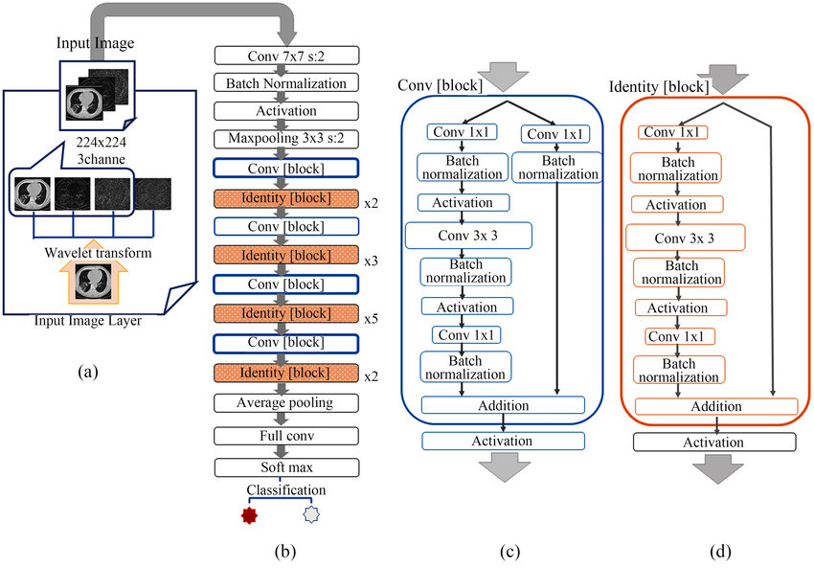

Fig.3.ResNet50 Architecture [4]

**5. Outcome of the Project:**

* Achieved **85–95% accuracy** in detecting COVID-19 from chest X-rays and CT scans.
* Efficient Net outperformed Dense Net in terms of **accuracy and computational efficiency**.
* Model successfully distinguished between **COVID-19, normal lungs, and pneumonia cases**.
* Developed a functional **web-based diagnostic tool** for easy access to predictions.  
  /*NOT YET DONE ABOVE MATTER ACTS AS PLACEHOLDER/*

1. **Challenges Faced:**

* **Limited Dataset** – The availability of publicly labeled COVID-19 X-ray images was limited, requiring extensive data augmentation.
* **Data Imbalance** – The dataset contained more non-COVID images, making the model prone to bias.
* **False Positives and Negatives** – Essential for medical diagnostics, requiring fine-tuning to minimize errors.
* **Hardware Constraints** – Training deep networks required **high GPU/TPU resources**, making it challenging to train on local systems.

1. **Future Enhancements:**

* **Multimodal Analysis** – Incorporate **clinical data (age, symptoms, oxygen levels)** along with X-ray and CT scans for better predictions.
* **Explainable AI (XAI)** – Improve model transparency using **Grad-CAM, SHAP, and LIME analysis**.
* **Lightweight Model Deployment** – Optimize models for **mobile devices and edge computing** for real-time diagnostics.
* **Cloud-Based API** – Develop a **scalable cloud API** for hospitals to **upload images and receive predictions remotely**.

1. **Conclusion:**

This project successfully demonstrates **deep learning-based COVID-19 detection** using chest X-ray and CT scans. The results show that **EfficientNet and DenseNet are highly effective** for medical image classification. The developed system has the potential to **assist healthcare professionals in faster and more accurate COVID-19 diagnosis**. With further improvements and deployment in hospitals, this AI-based approach can enhance **pandemic response, reduce testing costs, and improve healthcare accessibility** globally.

**References:**

[1] A. G. Howard, M. Sandler, G. Chu, L. C. Chen, B. Chen, M. Tan, W. Wang, Y. Zhu, R. Pang, V. Vasudevan, Q. V. Le, and H. Adam, “Searching for MobileNetV3,” *Proceedings of the IEEE/CVF International Conference on Computer Vision (ICCV)*, pp. 1314-1324, 2019. DOI: 10.1109/ICCV.2019.00140.

[2] J. Zhang, Y. Xie, Y. Li, C. Shen, and Y. Xia, “COVID-19 Screening on Chest X-ray Images Using Deep Learning-based Anomaly Detection,” *arXiv preprint*, arXiv:2003.12338, 2020. [arXiv:2003.12338](https://arxiv.org/abs/2003.12338).

[3] P. Rajpurkar, J. Irvin, K. Zhu, B. Yang, H. Mehta, T. Duan, D. Ding, A. Bagul, C. Langlotz, K. Shpanskaya, M. P. Lungren, and A. Y. Ng, “CheXNet: Radiologist-Level Pneumonia Detection on Chest X-Rays with Deep Learning,” *arXiv preprint*, arXiv:1711.05225, 2017. [arXiv:1711.05225](https://arxiv.org/abs/1711.05225).

[4] T. Zhou, S. Canu, and S. Ruan, “An automatic COVID-19 CT segmentation framework based on improved Res-UNet,” *International Journal of Imaging Systems and Technology*, vol. 31, no. 2, pp. 771-785, 2021. DOI: 10.1002/ima.22486.

[5] I. D. Apostolopoulos and T. A. Mpesiana, “Covid-19: automatic detection from X-ray images utilizing transfer learning with convolutional neural networks,” *Physical and Engineering Sciences in Medicine*, vol. 43, no. 2, pp. 635-640, 2020. DOI: 10.1007/s13246-020-00865-4.

[6] Loey, M., Smarandache, F., & M Khalifa, N. E. (2021). A deep transfer learning model for automatic detection of COVID-19 from chest CT scans. *Computers in Biology and Medicine, 132*, 104336. https://doi.org/10.1016/j.compbiomed.2021.104336